Responsible Officials: Managing Associated Consultants and Preparers
to Prepare Online Air Quality Permit Applications

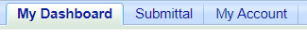
- Login and Navigate to the "My Account" Tab: This is located to the right of the "My Dashboard" tab (Figure 1).
Figure 1

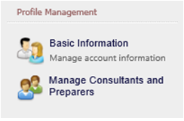
Provide Access to Consultants and Preparers: Under Profile Management, the Manage Consultants and Preparers section allows the Responsible Official (RO) to manage a list of associates (consultants and/or preparers) to help prepare Air permit applications. This section describes how a RO will associate and disassociate a preparer for his/her facility.
Figure 2

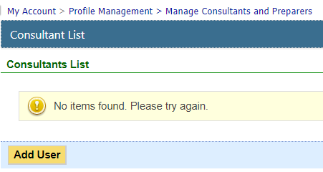
- Add Preparers: By clicking the Manage Consultants and Preparers link (Figure 2), the RO can see the preparers associated with their account.
Figure 3

If no one is identified, the list will be blank (Figure 3).
Click the button.

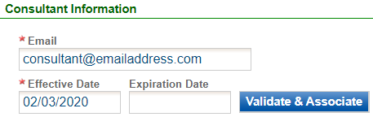
- Validate a New Preparer: The system first prompts for the preparer’s email address which means the preparer must have an account in EASY Air. Next, EASY Air asks for the effective or start date (required) and expiration date (optional) of this association (Figure 4).

Enter a start date (Effective Date) and click the button.
Figure 4

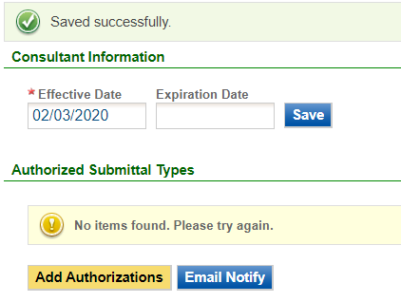
- Save the Preparer's Email & Date and Add Authorizations:
Figure 5
Click the button (Figure 5).

Select Facility and Type of Access:
The RO needs to add Authorized Submittal Types for the preparer.

‘Application Authorization’ defines the facility(s) and the application type(s) the preparer is allowed to work on (choose from 2 Title V & 15 Construction application types and permission access).
Click the button.

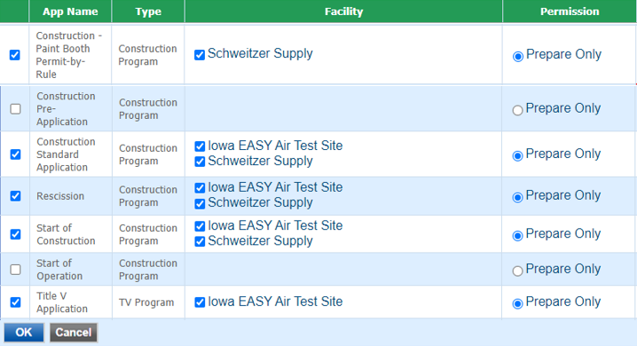
- Check All Facilities and Permit Types that Apply: This screen (Figure 6) shows all of the facilities and application types the RO wishes to assign to the Preparer.

*IMPORANT*
Check the boxes for App Name & Type, the Facility and the Prepare Only radio button for Permission.

All 3 items must be selected or the Preparer will not be able to access the facility or applications.

Click the button to proceed.
Figure 6

- Save and Notify Preparer: Once the association(s) are done, the consultant information (Figure 7) and then click the button to alert the new Consultant / Preparer of their access.
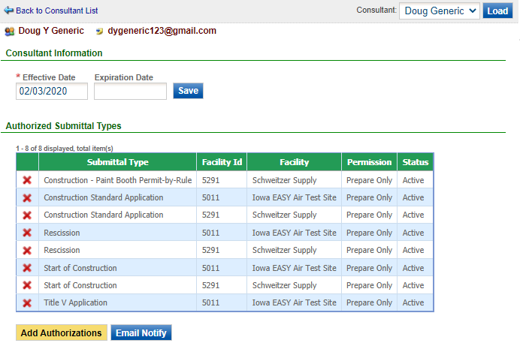
Figure 7

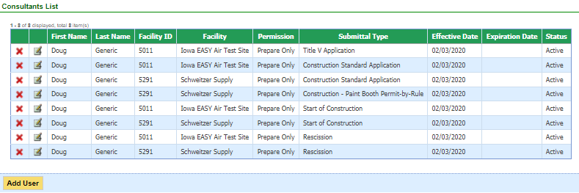
- View Information: Once Consultants and/or Preparers are associated with facility(s), click on the Manage Consultants and Preparers link again (Figure 2) to see a grid with associated preparers. Now the Responsible Official can view the facilities, application types and effective dates for each Consultant / Preparer association.
Figure 8

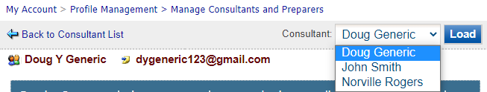
- View Consultant List: The Responsible Official may have multiple Consultants / Preparers assigned to work on specific facilities and permit applications. Switch between associated users by selecting the user’s name from the drop down list (Figure 9).
Figure 9

- Manage or Disassociate Preparer and Application Types: By clicking on the icon (Figure 10), the Responsible Official can pull up a detailed view of the associate’s settings in order to manage that Consultant's or Preparer's access to application types. The RO may also enter an Expiration Date to end that Consultant's / Preparer's association with a facility (Figure 7).
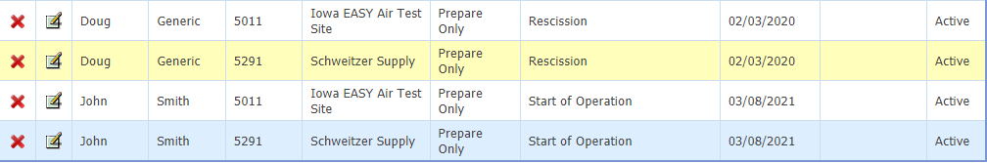
Figure 10
Figure 10
If the RO user wants to disassociate a Consultant or Preparer from an application type, the RO can simply click on the icon to remove the type from that Consultant's or Preparer's authorizations.

If you have questions, please call the Iowa EASY Air Helpdesk at 515-725-9569 or 515-204-3749.
Or send an email to easyair@dnr.iowa.gov.

